# Unit 3 Assignment: Deliverables

# Amon-ra

# Herzing University

BU 630-7A Project and Operations Management

Foreword

During my enrollment in this class, I was introduced to project and operations management. I became acquainted with the similarities and differences of projects and operations and the importance of each. The course clarified what is required to have a successful project, in support of the objectives of the company for it is through projects that companies evolve.

1. INTRODUCTION
   1. Introduction to High DHCP Utilization Response Project

Throughout the year, the company is host to a variety of events that involve stakeholders and current and potential business partners. To assist in providing a means communication to all persons visiting a company location, the company provides free access to our Wi-Fi network. When connecting to the network via a smartphone, tablet, or laptop, user will be automatically assigned an IP address via Dynamic Host Control Protocol (DHCP). The range of IP addresses per location are limited.

There has been reports of site visitors being unable to connect to the network. It has been discovered that some locations have receive a high number of visitors resulting in the exhaustion of available addresses.

* 1. Scope of Work

The High DHCP Utilization Response project is a proactive, rather than a reactive, initiative to resolve issues with company locations that exhibit high DHCP IP address utilization. The company does not desire to wait to take action until a location experiences a problem. The company prefers to act prior to a business having impact from a technical issue. All company locations will be monitored and an acceptable threshold will be set for all DHCP controllers.

Any location that meets or exceeds the threshold will generate an alert resulting in a proactive ticket being created. A new and permanent dedicated team will be assembled and assigned to resolving these issues. A standard operations procedure (SOP) will be created for the team to guide them in their troubleshooting. The SOP will contain a flow chart to provide a visual summarization of action to be taken by the team member assigned the alert ticket. The SOP will serve the training documentation to orient the team in the scope, troubleshooting, and revolve of DHCP issues.

1. DELIVERABLES
   1. DHCP Operations Team
   2. DHCP Operations Team Lead
   3. Standard Operations Procedure
   4. Training
2. PROJECT SCHEDULES

|  |  |  |
| --- | --- | --- |
| **TASK** | **ASSIGNED TO** | **TIME (days)** |
| Assemble Team | I.T. Shift Managers | 5 |
| Assign a Team Lead | I.T. Shift Managers | 3 |
| Create Distribution List (DL) | Messaging Team | 2 |
| Add Team Members to DL | Messaging Team | 2 |
| Provide Team Access to Inflobox | Network Security Team | 8 |
| Create SOP | Network Team Manager | 6 |
| Training | Network Team Manager | 7 |
| Creates the alert | Monitoring Department | 6 |
| Configure ticket & route ticket to team | Service Now Team | 6 |

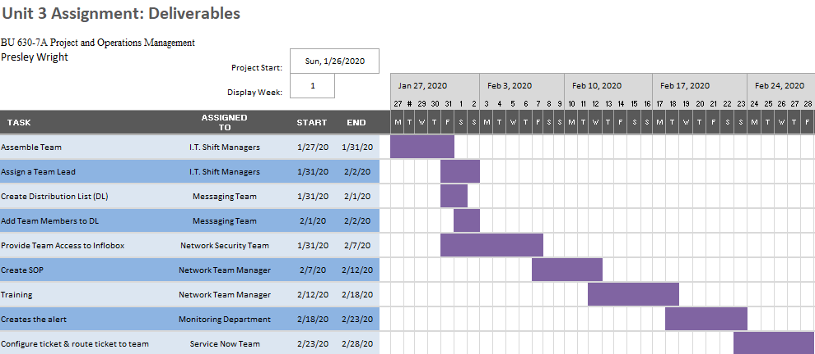

* Which of the articles gave what you believe to be the most value in relationship to critical path?

The article I believe to the most value in relationship to critical path is “The Critical Path Method: What It's All About” by Mark Lamendola. I found his explanation of a negative value in regards to Earliest Start, Earliest Finish, Latest Start, and Latest Finish to be very informative. Prior to reading this article, I only have an understanding of zero and was unaware that there could be a value of negative zero. Mark’s article expanded my knowledge and provided a more completed treatment of the topic.

* Based on what you have read in the chapters and in the articles do you see a relevant critical path for your project forming, if so explain what it might look like and roughly how many tasks will your project include?
  + Project scheduling is the phase where individual activities are defined. It follows the planning phase. The most common scheduling method is the Gantt chart. The Gantt chart is a very basic scheduling chart of activities therefor lacks complexity in the information it contains. It is inadequate for showing interdependencies between activities.
  + The network method of scheduling activities displays the relationships between activities. It is this method that is utilized to show the critical path and slack of project activities. The critical path method (CPM) exhibits those activities that are critical to the completion of the project. Such activities are unforgiving and they cannot be delayed and must be completed on time. Within the network method, these critical activities are in sequence connecting to one forming a path from start to finish. Any delays in activities the make up the critical path results in a delayed finish date.
* Will all of your critical tasks be deemed critical and will they potentially have dependencies?
  + - The critical path contains 6 critical activities: 1. Assemble Team, 2. Provide Team Access to Inflobox, 3. Create Standard Operating Procedure, 4. Training, 5. Creates monitoring alert, 6. Configure ticket & route ticket to team
  + All activities in the critical path are actually critical but not all activities have dependencies.
    - Assemble Team
      * No dependency due to be the starting point.
    - Provide Team Access to Inflobox
      * There first must be a team to provide access to.
    - Create Standard Operating Procedure
      * Dependency is based on needing to know the distribution list for accurate information in the SOP
    - Training
      * SOP must be created before training can take place.
    - Creates monitoring alert
      * No dependency.
    - Configure ticket & route ticket to team
      * Depends on monitoring being created. Tickets are generated via the alert.

Assemble Team

Time 5 days

v

Assign a Team Lead

Time 3 days

v

Create Distribution List (DL)

Time 2 days

v

Add Team Members to DL

Time 2 days

v

Provide Team Access to Inflobox

Time 8 days

v

Create Standard Operating Procedure

Time 6 days

v

Training

Time 7 days

v

Create Monitoring Alert

Time 6 days

v

Configure ticket & route ticket to team

Time 6 days

**Network Diagram**

Assemble Team

Time 5 days

v

Assign a Team Lead

Time 3 days

v

Create Distribution List (DL)

Time 2 days

v

Add Team Members to DL

Time 2 days

v

Provide Team Access to Inflobox

Time 8 days

v

Create Standard Operating Procedure

Time 6 days

v

Training

Time 7 days

v

Create Monitoring Alert

Time 6 days

v

Configure ticket & route ticket to team

Time 6 days

**Critical Path**

## References

## Gargiulo, G. R. (1965). Critical path methods. National Association of Accountants.NAA Bulletin (Pre-1986), 46(5), 3. Retrieved from https://prx-herzing.lirn.net/login?url=https://search.proquest.com/docview/198800989?accountid=167104

## Ghorbani, S. (n.d.). Critical Path MEthod. Retrieved January 26, 2020, from https://herzing.instructure.com/courses/7998/pages/unit-3-required-resources?module_item_id=459467

## Lamendola, M. (1998). The critical path method: What it's all about: Electrical construction and maintenance electrical construction and maintenance. Ec & M, 97(5), 3. Retrieved from https://prx-herzing.lirn.net/login?url=https://search.proquest.com/docview/206571649?accountid=167104

## Schroeder, R., Goldsetien, S. & Rungtusanatham, J. (2010). Operations Management: Operations Management in the Supply Chain: Decisions and Case, 6th edition

## Wallwork, J. W. (2002). Standards for a critical path method schedule: A publication of the american association of cost engineers a publication of the american association of cost engineers. Cost Engineering, 44(6), 13. Retrieved from https://prx-herzing.lirn.net/login?url=https://search.proquest.com/docview/220451964?accountid=167104.

## Waters, Barb. ( © 2016). Comptia project+ pk0-004: determining critical path and start/finish dates. [Books24x7 version] Available from http://library.books24x7.com/toc.aspx?bookid=109825.